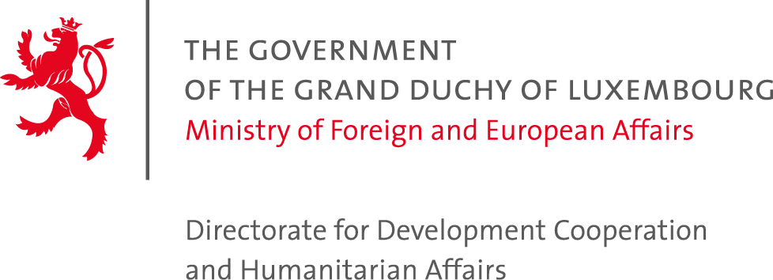
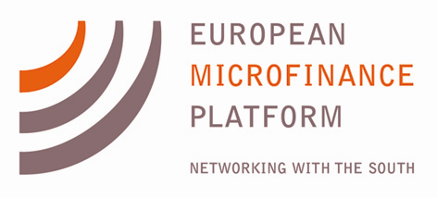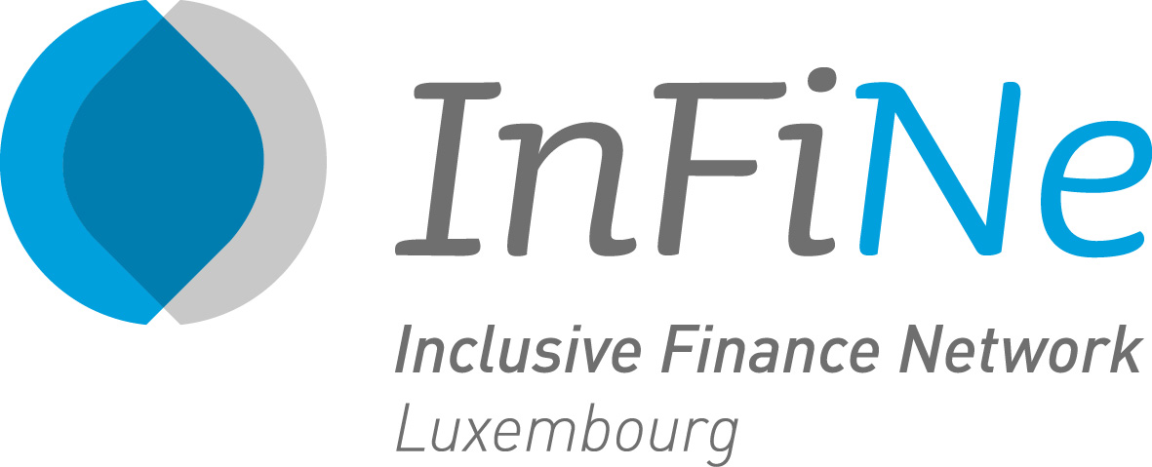

Press Release

Crédit Rural de Guinée, The First Microfinance Institution - Syria and TSKI from the Philippines announced as Finalists for 6th European Microfinance Award in Post-Disaster, Post-Conflict Areas & Fragile States

- Finalists demonstrating best practice and innovation in combining institutional resilience with that of their clients in vulnerable populations
- Winner to be announced at Ceremony at EIB on November 19th
- Record 47 applications from 28 countries received
Thursday, September 24, 2015
Luxembourg
FOR IMMEDIATE RELEASE
On Tuesday 22nd September, the Selection Committee for the 6th European Microfinance Award on Microfinance in Post-disaster, Post-conflict Areas & Fragile States, composed of members of the European Microfinance Platform (e-MFP) and Inclusive Finance Network Luxembourg (InFiNe.lu),) selected the three finalists who will go on to compete for the €100,000 prize. These three organisations are Crédit Rural de Guinée from Guinea, The First Microfinance Institution from Syria and Taytay Sa Kauswagan Inc. from the Philippines. The winner will be announced by the President of the High Jury Her Royal Highness The Grand Duchess of Luxembourg on November 19th, at a ceremony hosted at the European Investment Bank in Luxembourg, during the annual European Microfinance Week.
This year the objective of the Award is to highlight MFIs that operate in post-disaster/post-conflict areas and provide financial and non-financial services aimed to strengthen the resilience of the affected, vulnerable population. Serving clients in such markets is particularly difficult: institutions must effectively manage their operations, including managing increased portfolio risk, maintaining their physical infrastructure, staff, and access to funds - all the while staying focused on meeting the unique financial needs of clients affected by extreme events.
In light of the greatest refugee crisis since WWII engulfing the Middle East and Europe, along with the growing threat of climate change increasing the severity and frequency of natural disasters, there has never been a more important time to demonstrate best practice in this field.
Crédit Rural de Guinée (CRG) was hit by the Ebola virus outbreak beginning in early 2014. Unlike many others, CRG continued to operate, while taking special measures to prevent infection and protect both clients and staff. This included contacting clients and processing payments by phone, rescheduling loans for affected entrepreneurs (including cancelling debt in cases of death), continuing disbursement of new loans, and providing clients with the means to withdraw their savings. CRG also provided grants to the families of staff who were victims of Ebola. In addition, CRG launched a national awareness campaign to inform clients and the general population of measures to prevent the transmission of the virus. In total, over 4,000 people participated in these sessions. With support from the World Food Programme, CRG is currently distributing compensation to over 1000 Ebola survivors who continue to be stigmatised by their communities, as well as to 55,000 affected families.
The First Microfinance Institution – Syria (FMFI-S) has been operating in the country since 2003, including throughout the civil war that has ravaged the country and its people for the past four years. When its branch in Homs was destroyed, FMFI-S responded by opening two service units nearby to continue to provide clients with access to their savings and maintain loan repayments. It implemented a call centre to enable regular monitoring of its clients, including those whose homes or business were destroyed, who had lost family members, or were injured or killed. Relying on adjusted procedures that devolved power to branch managers, FMFI-S responded by rescheduling loans and providing grace periods of up to twelve months, modifying lending limits in response to inflation, and lending to new customers who had adapted their enterprises to the conflict. In the context of changing client needs, FMFI-S has continued to develop new products, including loans for solar panels, rent advances and others.
As Typhoon Haiyan headed towards the Philippines, Taytay Sa Kauswagan Inc. (TSKI) was still dealing with the aftermath of an earthquake that had affected 15 of its 98 branches. By the time the typhoon passed, another 46 branches had been hit. Despite this, TSKI advised all staff to go into the field to check on clients, while carrying aid in the form of food, goods and other relief products. It organised fresh water distribution, and worked in coordination with nurses and other volunteers. It ordered a temporary repayment moratorium for over 37,000 clients, and disbursed over 13,000 emergency loans. To spearhead home reconstruction, TSKI provided housing materials and credit, as well as flexi- and regular loans. Disaster assistance and specific disaster loans were also extended to 351 affected staff. Within two months, these various responses allowed thousands of clients to largely recover from the devastation to lives and property.
These three finalists were selected from an impressive list of semi-finalists, which also included: Al Amal Microfinance Bank, Yemen; Fonkoze, Haiti; Negros Women for Tomorrow Foundation (NWTF), Philippines; PAIDEK, Democratic Republic of Congo; Palestine for Credit and Development (FATEN), Palestine; Rural Finance Initiative, South Sudan; Standard Microfinance Bank, Nigeria.
This 6th edition of the Award, like all previous years, seeks to highlight organisations that excel in complex and valuable aspects of microfinance service provision, with practices not yet fully established and with institutions in these situations needing to improvise and innovate.
For this year's Award, a record 47 applications from 28 countries were received. After the announcement of the three finalists, the Luxembourg Minister for Development Cooperation and Humanitarian Affairs, Mr. Romain Schneider said:
“I am delighted that this year’s Award is addressing the remarkable work that is being done by microfinance institutions in post-disaster, post-conflict and fragile states. Despite the challenges encountered in these very difficult environments, the Award has attracted a record number of applications of an encouragingly high standard.
“The Award selection process has indeed been useful to evaluate and disseminate excellence in helping vulnerable populations through financial services. We hope that the practices highlighted will prove instrumental to other institutions that find themselves operating in these challenging situations.”
END
The European Microfinance Award was launched in 2005 by the Luxembourg Ministry of Foreign and European Affairs – Directorate for Development Cooperation and Humanitarian Affairs. It is jointly organized by the Luxembourg Development Cooperation, the European Microfinance Platform (e-MFP), and the Inclusive Finance Network Luxembourg (InFiNe.lu), in cooperation with the European Investment Bank.
Previous subjects for the Award have included Innovation for Outreach in 2006; Socially Responsible Microfinance (2008); Value Chain Finance (2010); Microfinance for Food Security (2012); and Microfinance and the Environment (2014).
See www.european-microfinance-award.com/

European Microfinance Platform:
Niamh Watters, nwatters@e-mfp.eu, +352 26271356. Website www.e-mfp.eu

Inclusive Finance Network Luxembourg:
Catherine Van Ouytsel, catherine.vanouytsel@infine.lu, +352 28371509. Website www.infine.lu

Ministry of Foreign Affairs and European Affairs, Directorate for Development Cooperation and Humanitarian Affairs:
Alexandra Allen, alexandra.allen@mae.etat.lu, +352 2478-2480. Website www.mae.lu

