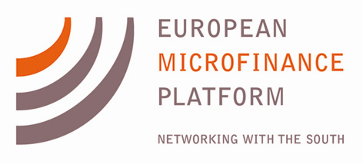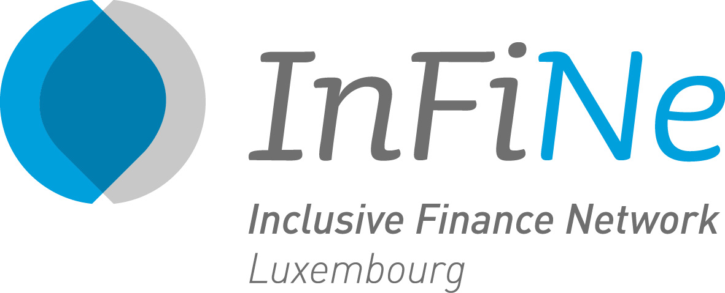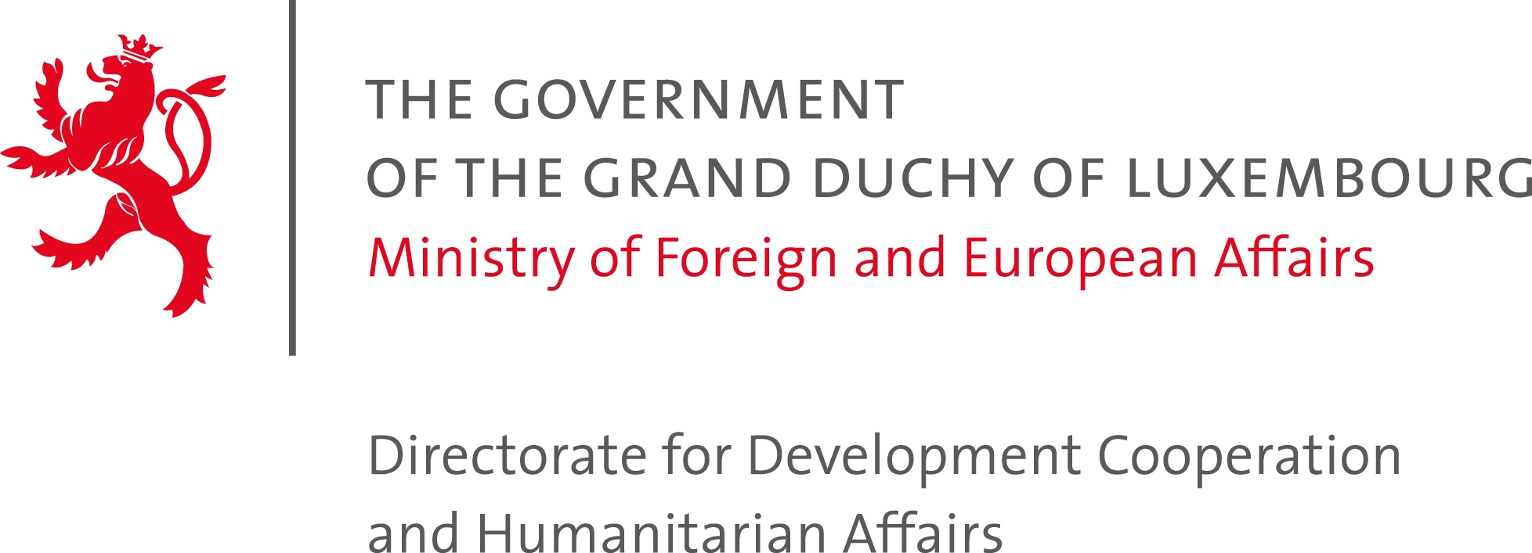

Press Release: Announcing the Finalists for the 5th European Microfinance Award: Microfinance and the Environment

On September 19th, the Second Selection Committee for the 5th European Microfinance Award on Microfinance and the Environment selected the three Finalists who will go on to compete for the €100,000 prize. The winner will be chosen by the High Jury on 13 November 2014, during the European Microfinance Week.
The three finalists are:
ESAF Microfinance and Investments, India: for the Clean Energy for the Poor initiative, providing rural clients with solar energy solutions, efficient cook stoves, and water filters. To date, over 60,000 clean energy products have been funded through microcredit to clients most of whom live on less than $2 a day. As a result, 25% of clients report spending less on energy, 50% report feeling healthier, and 40% spending less time collecting firewood, and thus more time for more productive activities. Clients also report better reading habits among children as a result of the solar lamps.
Kompanion Financial Group, Kyrgyzstan: for the Pasture Land Management Training Initiative, which provides a specialized "Credit for Conservation" loan linked to a training program for livestock farmers on grazing land management and preservation. Under this program, Kompanion works to address widespread land degradation in the country, particularly adjoining rural villages. Since the launch of the program in 2011, more than 24,000 farmers have participated in the trainings, increasing their incomes by 30%.
XacBank LLC, Mongolia: for the Eco Product Program, under which it has facilitated the purchase of over 150,000 energy efficient heating and insulation products to poor ger district households in Ulaanbaatar (gers are traditional nomadic yurts that are costly and highly polluting to heat with traditional coal stoves.) By providing microcredit to families who otherwise spend up to 45% of their income on heating during the winter months, XacBank has not only helped these families reduce their heating expenses, but also reduced carbon emissions by an estimated 380,000 tons and lowered particulate pollution by 90%.
For this year's Award, e-MFP received 26 applications from 19 countries. The Luxembourg Minister of Development Cooperation, Mr. Romain Schneider said "We are very pleased with the response and level of interest in this year’s topic. Environmental changes disproportionately affect the poorest people in developing countries, and this year’s finalists show how microfinance institutions can improve the livelihoods of their clients, help build more resilient communities, and contribute to a more sustainable environment. The objective of the Award – to support and encourage innovative thinking in the sector – remains as important as ever."
The European Microfinance Award was launched in 2005 by the Luxembourg Ministry of Foreign and European Affairs – Directorate for Development Cooperation and Humanitarian Affairs. It is jointly organized by the Luxembourg Development Cooperation, the European Microfinance Platform (e-MFP), and the Inclusive Finance Network Luxembourg (InFiNe.lu), in cooperation with the European Investment Bank.

